**Materials and methods**

**1. Sampling**

The material was collected in the Atlantic Ocean and the southwestern part of the Indian Ocean during 5 research cruises in 2013th-2020th (see Fig. 1 and Table 1 in the Appendices) using the Bogorov-Rass plankton net (mouth area – 1 m2, 500 μm mesh size) or the Isaacs-Kidd midwater trawl (mouth area - 5.5 m2, mesh size - 5 mm). A total of XX *S. dedilis* were sorted from bulk samples and fixed in 96% ethanol. Spesimens were stored at -20°C in the laboratory. Species identification was performed using the key of Lunina et al. (2019).

**2. DNA extraction, ampliphication and sequencing**

DNA was isolated either from the fifth pair of pleopods or from abdominal muscle tissue using the IG-Spin™ DNA Prep 200 kit for DNA extraction following the manufacturer’s protocol. The isolated DNA was used as a matrix for the amplification of the mitochondrial cytochrome *c* oxidase subunit I gene fragment I (COI), and the nuclear gene of the first internal transcribed spacer (ITS-1). PCR amplification of the COI gene fragment was accomplished with the universal primers LCOI 1490 (GGTCAACAAATCATAAAGATATTGG) and HCOI 2198 (TAAACTTCAGGGTGACCAAAAAATCA) (Folmer et al., 1994) or decapod-specific primers COL6 (5’-ACAAATCATAAAGATATYGG-3’) and COH6 (5’-TADACTTCDGGRTGDCCAAARAAYCA-3’) (Schubart et al, 2006) in cases where the former failed. The primers ITS1FW (5'-CACACCGCCCGTCGCTACTA-3') and ITS3R (5′-TCGACSCACGAGCCRAGTGATC-3′) (Wormhoudt et al, 2019) were used to amplify the ITS-1 gene. PCR reactions were performed in a reaction volume of 20 μl, containing XX μl of the Encyclo Plus PCR kit (Eurogen, Russia), 0.2 μl of each primer, 1.6 μl of DNA template, 15.3 μl MilliQ water, and 0.3 μl of 50X Encyclo polymerase (Eurogen, Russia). The PCR cycling profiles and annealing temperatures are listed in Table XX. The PCR products were purified and sequenced with the same primer sets of amplification on an ABI Prism 3500 xl automatic genetic analyzer. Forward and reverse COI and ITS-1 sequences were assembled in Geneious® 7.1.3. and manually treated for ambiguities and heterozygotes (in the case of ITS-1). Also, COI sequences were checked for stop codons using Geneious® 7.1.3 software. A total of 73 consensus sequences for the COI gene and 23 sequences for ITS-1 were obtained and deposited in the NCBI GenBank database (Table X).(accession numbers: XX-XX)

**3. Sequence alignment and phylogenetic analyses**

For the phylogenetic analysis, all available sequences of *S. debilis* and *S. liui* (no. KT946751) were taken from the GenBank (<https://www.ncbi.nlm.nih.gov/genbank/>). Two species of the superfamily Oplophoroidea, *S.curvispina* (no. KP076159) and *Acanthephyra quadrispinosa* (no. KP076178), were chosen as outgroups to root the tree. Multiple alignment of all sequences was performed in Geneious® 7.1.3 using the MUSCLE algorithm (Edgar, 2004) (25 repeats). The final alignment for the COI fragment was 539 bp and included 109 sequences, and for the ITS-1 fragment, 23 sequences of 328 bp. In the case of the ITS-1 gene, no sequences of this marker for *S. debilis* were found in available resources, so only newly obtained sequences were analyzed. Since the variability of this fragment turned out to be low, we considered the construction of a haplotype network to be the most convenient way to visualize the obtained results.

Phylogenetic reconstruction of the COI gene by the Maximum likelihood (ML) was performed with the RAxML (ver. 7.2.8 (Stamatakis, 2006)) using the GTR+G nucleotide substitution model for each codon position. Statistical support was assessed using the bootstrap method involving 1000 replicates. Bootstrap values greater than 70% were considered statistically significant. Before the Bayesian analysis was performed on the COI sequences, the most appropriate nucleotide substitution models and the most appropriate partitioning scheme were selected for each codon with the use of the Akaike Information Criterion (AICc) in the PartitionFinder2 software (Guindon et al., 2010; Lanfear et al., 2017). As a result, the nucleotide substitution patterns were as follows: GTR+I+G for the first codon, GTR+I for the second, and GTR+G for the third. Bayesian analysis was performed in MrBayes 3.3 software (Huelsenbeck and Ronquist, 2001). Two parallel runs of 10,000,000 generations with tree selection every 1,000 generations were performed, and the first 25% of trees were excluded from the calculation of posterior probabilities. The final phylogenetic reconstructions were visualized in Mega5 software.

The PopArt Software (http://popart.otago.ac.nz/, (Bandelt, Forster, and Röhl, 1999)) was used to construct the haplotype network using the neighbor-joining (NJ) method. Haplotype diversity was analyzed in DNASP ver. 5 (Librado, 2009) separately for the North Atlantic and Indian Ocean geographic group. Genetic diversity analysis were performed in the MEGA11 (Tamura, 2021) using a two-parameter Kimura model (K2P) (Kimura, 1980).

**4. Morphological analysis**

To assess within-species morphological variability of *S. debilis*, the characters that are taxonomically significant for the family Oplophoridae (Lunina, Kulagin, and Vereshchaka, 2018) and that are potentially most variable within the species were selected. A total of 32 traits referred to 5 groups were measured under the stereoscope (Olympus SZ) in each collected specimen: (1) carapace (carapaceheight, carapacelength, total number of the dorsal teeth on rostrum, number of the postorbitalteeth on the dorsal side of the rostrum, number of the rostralteeth on the ventral side), (2) abdomen (presence of the dorsalcarina on the thirdabdominalsomite, number of serrationsonlateralmargin of the 4th and 5th abdominal somites on the left and right sides, presence of a sharptoothonposteriormarginof thepleonof the 5th abdominalsomite on the left and right sides) (3) antenna (presence of a scaphocerite on the lateralmargin of the antenna’s exopod), (4) telson (number of the dorso-lateralspines, presence of the numerouslateralspinesarrangedintwoormorerows), (5) pereopods (number of the movable spines at ischium, caprus and merus of 3rd – 5th pair of pereopods at the anterior and posteriorrows). The traits are listed in Table 6 in the Appendices. The carapace length was measured from the posterior edge of the eye orbit to the posterior edge of the carapace; the carapace height was measured at the widest point. For the obtained data see the table (see Tables 7-9 in the Appendices). In several cases shrimps had a broken rostrum, and one or more pereopods were lost.

Statistical analyses of morphological data and comparisons of the morphological and genetic traits were performed using R 4.0.5 (R Core Team, 2021). In specimens that were missing one or more morphological traits, they were replaced by the mean values of the traits (Legendre, Legendre, 2012). The total proportion of missing values was 1.2% of all trait values. The juveniles (individuals with carapace lengths less than 5 mm) were removed from the analysis to reduce noise. The traits with no variance were also removed from the analysis.

Since the morphological traits may have a high correlation with the size of individuals, the following approach was applied to remove the effect of the size. Two variables were taken as a characteristic of the size of individuals: the carapace length and the carapace height. These two body parameters were considered as the predictors in the canonical correlation analysis (CCA) (González, 2008), while the other morphological parameters (28 traits) were considered as the matrix of the dependent variables. The analysis was performed using the ~~RDA~~  rda() function from the “vegan” package (Oksanen et al., 2020). The analysis yielded constrained axes (CCA1 and CCA2) and 26 unconstrained axes. As the canonical axes are related to the influence of the size of individuals in contrary to the unconstrained axes that describe the structure of the residual matrix from the regression models therefore describing the relationship between traits after removing influence of size ~~each of the morphological traits and predictors~~) both the canonical axes (CCA1 and CCA2) were excluded from the further analysis. Since the focus of the analysis was on morphological traits, with the influence of body size excluded from them, we further addressed to the first two unconstrained axes (CA1 and CA2) that were the most informative. So the further ordination of the individuals and the traits was considered in the CA1 and CA2 space.

The Mantel test (Legendre, Legendre, 2012) was applied to assess the relationship between the morphological traits of the shrimps and their genetic characteristics. For this purpose, two distance matrices were obtained. The first matrix included Euclidean distances between individuals in CA1 and CA2 space. This matrix consisted of square roots of pairwise genetic distances between the sequences of the COI gene in the sequence alignment. Genetic distances were calculated using the dist.alignment() function from the “seqinr” package (Charif, Lobry, 2007). The mantel correlation between the two matrices was calculated using the ~~Mantel~~ mantel() function from the “vegan” package (Oksanen et al., 2020). The statistical significance of the test was assessed using the permutation method (9999 permutations). Visualization of the results of the statistical analysis was performed using functions from the package "ggplot2" (Wickham, 2016).

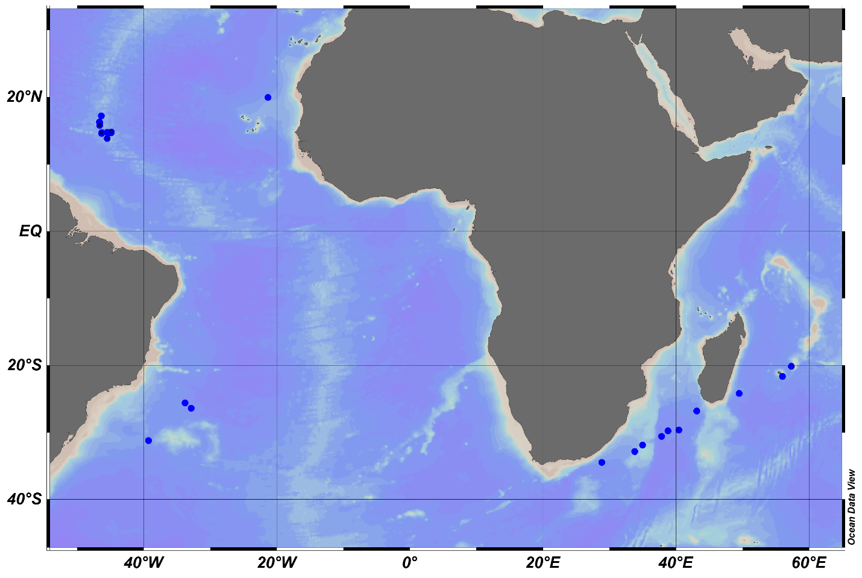

Figure 1. Sampling localities of *S. debilis*. ZZ circles indicate the collection sites of the specimens retrieved from GenBank.

Pic.1. A material collection map as well as an occurrence map of S.debilis individuals was created using Ocean Data View software (ODV, version 5.6.2, Schlitzer, Reiner, Ocean Data View, odv.awi.de, 2021).